CONTENTS

1) Introduction.................................................................................................................................3
1.1) Some Words On Biology Of Brain.....................................................................................3
2) Concept of BCI..............................................................................................................................4
3) BCI Research.................................................................................................................................5
3.1) Early Work.......................................................................................................................5
3.3) Prominent Research successes..........................................................................................5
4) Cortical Plasticity............................................................................................................................6
5) Impact Analysis...............................................................................................................................7
6) Human BCI Research......................................................................................................................8
6.1) Non-Invasive......................................................................................................................8
6.1.1) Electroencephalography................................................................................................8
6.1.2) FMRI Based BCI...........................................................................................................8
6.1.3) MEG Based BCI.............................................................................................................8
6.2) Invasive BCI Research............................................................................................................8
6.2.1) Electrocorticography (ECoG) .......................................................................................8
6.2.2) Light Reactive Imaging................................................................................................8
7) Ratbot................................................................................................................................................9
8) Principle of BCI operation...............................................................................................................10
9) Scheme of BCI..................................................................................................................................11
9.1) Pre-Processing..........................................................................................................................11
9.2) Classification.............................................................................................................................11
9.3) Translation Algorithm...............................................................................................................11
10) Brain Gate Technology...................................................................................................................12
11) Sensory Input...................................................................................................................................13
12) BCI vs Neuroprosthetics................................................................................................................14
13) BCI Innovators...............................................................................................................................15
14) Drawbacks......................................................................................................................................16
15) Ethical Consideration.....................................................................................................................17
16) BCI Outlook...................................................................................................................................18
17) Cell Culture BCI.............................................................................................................................20
18) References......................................................................................................................................20

1. Introduction
Star Trek or Matrix trilogy may have served the entertainment quotient well but what has been gained from it is technology for those physically challenged section of society for whom there is enough pity but not enough, It may be said that they form measly 7 % of the society but in figures they amount to hundreds of millions. Less than a decade ago, hardly anyone could have predicted that attempts to build direct functional interfaces between brains and artificial devices, such as computers and robotic limbs, would have succeeded so readily, and in the process would have led to the establishment of a new area at the frontier of systems neuroscience. Born as a highly multidisciplinary field, basic research on brain–computer interfaces (BCIs) has moved at a stunning pace. This interest stems from the considerable potential of this technology for restoration of motor behaviours in severely handicapped patients, particularly those suffering from devastating conditions such as amyotrophic lateral sclerosis (ALS), spinal cord injury, stroke and cerebral palsy. As this technology advances and the risks of invasive brain recordings decrease, BCIs might also hold promise for amputees[5]. In addition to the systems controlling upper limb prostheses, BCIs dedicated to the restoration of locomotion and speech are likely to emerge.
A BCI system allows individuals with motor disabilities to control objects in their environments (such as a light switch in their room or television, wheelchairs, neural prosthesis and computers) using their brain signals only. This could be accomplished by measuring specific features of the user’s brain activity that relate to his/her intent to perform the control. Direct neural interface devices were the prominent feature of the popular Matrix film series, wherein humanity was enslaved by artificially intelligent robots in a virtual world piped directly into people's brains. These interfaces are an extremely common element of cyberpunk fiction, often characterised as "control of hardware at speed of thought". In the meme wars novels of John Barnes, direct mind-computer interface permits the emergence of a hegemonic collective mind called One True. The ability to control or move certain objects by mere thought is an attribute of (in many cases alien) lifeforms that is often portrayed in science fiction movies. The issue of turning this idea into science fact has become more and more popular over the last couple of years. However, the prosaic, scientific view of this does not involve any mystic, telepathic power (of course). Scientists are trying to devise systems that record and analyze the brain electrical activity of a subject – represented by tiny voltages (i.e. numbers), measured at consecutive points in time – with the help of a computer. Since such a system tries to somehow convert the thoughts of the human being in front of the computer into a machine-readable format, it is called a brain-computer interface. The idea of direct brain-computer communication was first mentioned in, and nowadays, more than 20 research groups all over the world are working on this problem. Numerous articles in newspapers or scientific magazines are presenting different approaches and first promising results from those groups. In this context, even the slightest hint at a working device (though extremely slow and not terribly accurate, with often immense hardware requirements) is applauded as a huge success. This report comments on the entire range of aspects of a BCI, and since developing a BCI combines a huge variety of different disciplines (such as medicine, biology, computer science, physics, mathematics, electrical and mechanical engineering) that “range” is terribly large. It is therefore virtually impossible to keep track of everything written and published in this field, and any comprehensive work on BCI’s (which this report is intended to be) necessarily has to be incomplete.

1.2 Some Words On the Biology Of Brain
The human brain contains a huge network of billions of nervous cells (also called neurons). A typical neuron is
depicted in. A neuron consists of several dendrites (often called dendritic tree because of its typical shape), a cell body (or soma), and an axon[2], which may be as short as (in the case of neurons in the central nervous system) and sometimes as long as (e.g. in the case of some peripheral nerves going to muscles in the leg). The dendrites of a neuron are connected to the axons of several other (“predecessor”) neurons, and the contacts between axons and dendrites are called synapses.
One may think of a neuron as a simple binary processing unit. In this respect, the dendrites represent some sort of input channels, while the axon carries a binary output information. Each neuron calculates a weighted sum of the input signals coming from its predecessors (where the weights are “stored” in the synapses, which may be either excitatory or inhibitory with varying strength) and determines, whether or not this sum exceeds a certain threshold. If so, the neuron outputs a “1” down its axon – the neuron is then said to be “firing”. Signal transmission in the brain involves the displacement of differently polarized ions, and therefore, action potentials coming from firing neurons generate electric fields. If a human thinks about a certain thing, hears, sees, does or says anything, has certain emotions or simply: if he or she is alive, different neurons get activated and interact with one another.
2. Concept of BCI
Fig.1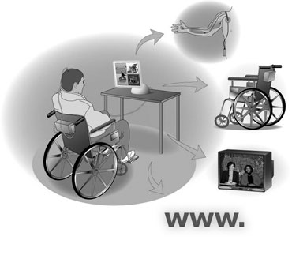
A brain-computer interface (BCI), sometimes called direct neural interface or brain-machine interface is direct communication pathway between human or animal brain and an external device. Think of a brain-computer interface as a device that is entirely realized in hardware, where the application involves an operation providing a “surgical connection” between the brain of the user and a (probably remotely operated) computer [3].
Resulting in measurable signals, an alternative (operation-free) possibility for devising a brain-computer interface exists. It is based on the monitoring of the brain-electrical activity of the user (To be polite, this is a very futuristic and optimistic view of the progress in medicine. Our current knowledge of the functions of the brain and the interactions of the nervous cells is extremely limited. Moreover, microscopically identifying individual neurons, determining their exact functions, and connecting them to a computer chip, is something that not even a team of the best surgeons around the globe can do. “Never” might be the wrong word, but based on present knowledge, it seems to be highly unlikely that this ever becomes possible, and it is no wonder that the first positive results concerning attempts to make paraplegics walk again originate from an approach involving the external stimulation of leg muscles, not relying on surgically bridging the gap between wounded nervous tracts[2].
Since the interactions of neurons are based on electrical processes which is influenced by his or her thoughts and extracting commands to control computer functions. This concept characterizes the usual type of system that is referred to by the term braincomputer interface (BCI).

3. BCI research
Several laboratories have managed to record signals from monkey and rat cerebral cortexes in order to operate BCIs to carry out movement. Monkeys have navigated computer cursors on screen and commanded robotic arms to perform simple tasks simply by thinking about the task and without any motor output. Other research on cats has decoded visual signals[5].

3.1 Early work
Studies that developed algorithms to reconstruct movements from motor cortex neurons, which control movement, date back to the 1970s. Work by groups led by Schmidt, Fetz and Baker in the 1970s established that monkeys could quickly learn to voluntarily control the firing rate of individual neurons in the primary motor cortex via closed-loop operant conditioning, a training method using punishment and rewards.
In the 1980s, Apostolos Georgopoulos at Johns Hopkins University found a mathematical relationship between the electrical responses of single motor-cortex neurons in rhesus macaque monkeys and the direction that monkeys moved their arms (based on a cosine function). He also found that dispersed groups of neurons in different areas of the brain collectively controlled motor commands but was only able to record the firings of neurons in one area at a time because of technical limitations imposed by his equipment.
There has been rapid development in BCIs since the mid-1990s. Several groups have been able to capture complex brain motor centre signals using recordings from neural ensembles (groups of neurons) and use these to control external devices, including research groups led by Richard Andersen, John Donoghue, Phillip Kennedy, Miguel Nicolelis, and Andrew Schwartz.

3.3 Prominent research successes
Phillip Kennedy and colleagues built the first intracortical brain-computer interface by implanting neurotrophic-cone electrodes into monkeys.
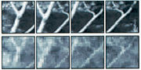
Fig.2
Yang Dan and colleagues' recordings of cat vision using a BCI implanted in the lateral geniculate nucleus, In 1999, researchers led by Yang Dan at University of California, Berkeley decoded neuronal firings to reproduce images seen by cats. The team used an array of electrodes embedded in the thalamus (which integrates all of the brain’s sensory input) of sharp-eyed cats. Researchers targeted 177 brain cells in the thalamus lateral geniculate nucleus area, which decodes signals from the retina. The cats were shown eight short movies, and their neuron firings were recorded. Using mathematical filters, the researchers decoded the signals to generate movies of what the cats saw and were able to reconstruct recognizable scenes and moving objects. Similar results in humans have been since then achieved by researchers in Japan.
Miguel Nicolelis has been a prominent proponent of using multiple electrodes spread over a greater area of the brain to obtain neuronal signals to drive a BCI. Such neural ensembles are said to reduce the variability in output produced by single electrodes, which could make it difficult to operate a BCI.
After conducting initial studies in rats during the 1990s, Nicolelis and his colleagues developed BCIs that decoded brain activity in owl monkeys and used the devices to reproduce monkey movements in robotic arms. Monkeys have advanced reaching and grasping abilities and good hand manipulation skills, making them ideal test subjects for this kind of work.
By 2000, the group succeeded in building a BCI that reproduced owl monkey movements while the monkey operated a joystick or reached for food. The BCI operated in real time and could also control a separate robot remotely over Internet protocol. But the monkeys could not see the arm moving and did not receive any feedback, a so-called open-loop BCI.
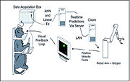
Fig.3
Later experiments by Nicolelis using rhesus monkeys[5], succeeded in closing the feedback loop and reproduced monkey reaching and grasping movements in a robot arm. With their deeply cleft and furrowed brains, rhesus monkeys are considered to be better models for human neurophysiology than owl monkeys. The monkeys were trained to reach and grasp objects on a computer screen by manipulating a joystick while corresponding movements by a robot arm were hidden. The monkeys were later shown the robot directly and learned to control it by viewing its movements. The BCI used velocity predictions to control reaching movements and simultaneously predicted hand gripping force.
Other labs that develop BCIs and algorithms that decode neuron signals include John Donoghue from Brown University, Andrew Schwartz and Richard Andersen from Caltech. These researchers were able to produce working BCIs even though they recorded signals from far fewer neurons than Nicolelis (15–30 neurons versus 50–200 neurons).
Donoghue's group reported training rhesus monkeys to use a BCI to track visual targets on a computer screen with or without assistance of a joystick (closed-loop BCI). Schwartz's group created a BCI for three-dimensional tracking in virtual reality and also reproduced BCI control in a robotic arm. The group created headlines when they demonstrated that a monkey could feed itself pieces of zucchini using a robotic arm controlled by the animal's own brain signals.
Andersen's group used recordings of premovement activity from the posterior parietal cortex in their BCI, including signals created when experimental animals anticipated receiving a reward.
In addition to predicting kinematic and kinetic parameters of limb movements, BCIs that predict electromyographic or electrical activity of muscles are being developed. Such BCIs could be used to restore mobility in paralyzed limbs by electrically stimulating muscles.
Miguel Nicolelis worked with John Chapin, Johan Wessberg, Mark Laubach, Jose Carmena, Mikhail Lebedev, Antonio Pereira, Jr., Sidarta Ribeiro and other colleagues showed that activity of large neural ensembles can predict arm position. This work made possible creation of brain-machine interfaces - electronic devices that read arm movement intentions and translate them into movements of artificial actuators. programmed the neural coding in a brain-machine interface allowed a monkey to control reaching and grasping movements by a robotic arm, argued that brain networks reorganize to create a new representation of the robotic appendage in addition to the representation of the animal's own limbs.
A new 'wireless' approach uses light-gated ion channels such as Channel to control the activity of genetically defined subsets of neurons in vivo. In the context of a simple learning task, illumination of transfected cells in the somato sensory cortex influenced the decision making process of freely moving mice.

4. Cortical Plasticity
For years, the brain of an adult human was viewed as a static organ. When you are a growing, learning child, your brain shapes itself and adapts to new experiences, but eventually it settles into an unchanging state -- or so went the prevailing theory. Beginning in the 1990s, research showed that the brain actually remains flexible even into old age. This concept, known as cortical plasticity, means that the brain is able to adapt in amazing ways to new circumstances. Learning something new or partaking in novel activities forms new connections between neurons and reduces the onset of age-related neurological problems. If an adult suffers a brain injury, other parts of the brain are able to take over the functions of the damaged portion.

5. Impact Analysis
The most immediate beneficiaries of such a system are patients with “locked-in syndrome” or other disabilities who are unable to communicate through traditional means. A non-invasive brain-computer interface will allow these patients to communicate reliably without learning to operate unfamiliar systems or undergoing the risk of brain surgery for implanted connections.
Further benefits can accrue to able-bodied users if the technology advances sufficiently. Interest in developing more efficient man-machine interfaces has existed since the development of rudimentary brain imaging systems in the 1950s. A silent, “telepathic” interface between a human and a computer has the potential to revolutionize the means by which humans interact with computers in every way. Instead of interacting via traditional interface methods such a keyboard, users could simply imagine speaking a request to the computer and it would appear on the screen. In addition to being more rapid, it would be useful in situations where communication is necessary but overt speech or action is impossible. Additional technology will be necessary, but our work provides a proof-of-concept demonstrating that such an
interface is viable.
Additionally, the development of our system in particular will answer a number of long-standing open questions in cognitive neuroscience, for example, whether or not the intended motor action recorded from single-electrode implants in animals is equivalent to imaginary motor action recorded via EEG in humans.

6. Human BCI research

6.1 Non-invasive
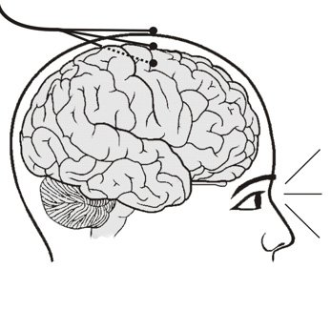
Fig.4
6.1.1 Electroencephalography
Non-invasive systems primarily exploit electroencephalograms (EEGs) to control computer cursors or other devices. This approach has proved useful for helping paralyzed or’ locked in’ patients develop ways of communication with the external world. However, despite having the great advantage of not exposing the patient to the risks of brain surgery, EEG-based techniques provide communication channels of limited capacity. Their typical transfer rate is currently 5–25 bits. Although such a transfer rate might not be sufficient to control the movements of an arm or leg prosthesis that has multiple degrees of freedom, past and recent research in this field seems to indicate that EEG-based BMIs are likely to continue to offer some practical solutions (e.g. cursor control, communication, computer operation and wheelchair control) for patients in the future.
Training to operate EEG-based BCIs can take many days. Visual feedback is the essential part of such training. Some BCI designs rely on the subjects’ ability to develop control of their own brain activity using biofeedback, whereas others utilize classifier algorithms that recognize EEG patterns related to particular voluntary intentions. Recently, adaptive algorithms that constantly update the classifier parameters during training have been implemented.
Several strategies have also been proposed to provide feedback to users of EEG-based BCIs. For instance, virtual-reality systems can provide a realistic feedback that can be efficient for BCI training. In a recent demonstration of this approach, subjects navigated through a virtual environment by imagining themselves walking.
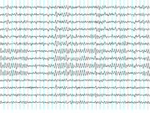
Fig. 5
Recordings of brainwaves produced by an electroencephalogram
Electroencephalography (EEG) is the most studied potential non-invasive interface, mainly due to its fine temporal resolution, ease of use, portability and low set-up cost. But as well as the technology's susceptibility to noise, another substantial barrier to using EEG as a brain-computer interface is the extensive training required before users can work the technology. For example, in experiments beginning in the mid-1990s, Niels Birbaumer of the University of Tübingen in Germany used EEG recordings of slow cortical potential to give paralysed patients limited control over a computer cursor. (Birbaumer had earlier trained epileptics to prevent impending fits by controlling this low voltage wave.) The experiment saw ten patients trained to move a computer cursor by controlling their brainwaves. The process was slow, requiring more than an hour for patients to write 100 characters with the cursor, while training often took many months.
Another research parameter is the type of waves measured. Birbaumer's later research with Jonathan Wolpaw at New York State University has focused on developing technology that would allow users to choose the brain signals they found easiest to operate a BCI, including mu and beta waves.
A further parameter is the method of feedback used and this is shown in studies of P300 signals. Patterns of P300 waves are generated involuntarily (stimulus-feedback) when people see something they recognize and may allow BCIs to decode categories of thoughts without training patients first. By contrast, the biofeedback methods described above require learning to control brainwaves so the resulting brain activity can be detected.
Lawrence Farwell and Emanuel Donchin developed an EEG-based brain-computer interface in the 1980s. Their "mental prosthesis" used the P300 brainwave response to allow subjects, including one paralyzed Locked-In syndrome patient, to communicate words, letters, and simple commands to a computer and thereby to speak through a speech synthesizer driven by the computer. A number of similar devices have been developed since then. In 2000, for example, research by Jessica Bayliss at the University of Rochester showed that volunteers wearing virtual reality helmets could control elements in a virtual world using their P300 EEG readings, including turning lights on and off and bringing a mock-up car to a stop. Because brain imaging systems to date, including EEG,have been unable to identify activity generated by patterns of human thought or language in the brain, efforts at developing systems to communicate in natural-language has been written off as impossible. Because the signals generated by thought are so weak and the biological mechanisms are poorly understood, gathering these signals with EEG was demonstrated to be an infeasible means of gathering data from the brain.
Work to date has instead focused on reading signals associated with imaginary motor activity unrelated to linguistic communication. One typical system allows users to navigate a menu by performing a mental computation or imagining motion of the left arm, right arm, left leg, or right leg respectively to indicate a choice. Although the motor signals associated with imaginary motion allow users to communicate, these systems are suboptimal. Users must train extensively to learn to communicate using the devices associated with the system and operate relatively slowly due to the limited number of choices available at any given time. Instead, we present a design for an EEG-based system that permits users to communicate naturally in a language that is familiar to them. Although we cannot read signals associated with the direct generation of language, we are able to read signals associated with corresponding necessary motor actions.
With sufficiently high resolution, a brain imaging system could in theory distinctly identify the position of the lips and tongue during speech by examining brain activity. This information can then be translated into computer- or human-legible text or speech. Unfortunately, because motor activity of the lips during speech is fairly precise and subtle, the resolution required would be very advanced. As current imaging technology does not offer such a resolution, we propose to demonstrate the feasibility of this concept by examining an equivalent system – sign language. Recent achievements in animal studies using invasive electrodes to take readings suggest that neural signals associated with intended motor action can suffice to activate a brain-computer interface. It remains to be seen whether or not readings from intended motor action are sufficient to distinguish using EEG, and whether or not the strength of these signals will be improved with user adaptation to the system. If so, the system will be able to translate the intentions of the user to communicate directly into speech without the need for the corresponding physical activity to take place. This work intends to serve as a proof-of-concept that with sufficiently high resolution imaging, motor activity associated with verbal speech could be translated into computer comprehensible format.
Pros
- Low set up cost
- Ease of use
- Portability
Cons
- Susceptibility to noise
- Extensive training required

6.1.2 fMRI based BCI

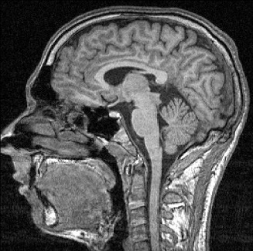
Fig.6
In fMRI we Detect changes in blood flow and blood oxygenation (i.e. haemodynamics) in the brain. Due to changes in oxygen levels in hemoglobin magnetic resonance is generated. Image intensity variations show brain activation areas which could be translated for BCI application .This method is not so popular because of
- Bulky scanner
- Too slow vascular response - local response to this oxygen utilisation occurs after a delay of approximately 1-5 seconds, with peaks at 4-5 s
- Possible detrimental effects due to prolonged exposure
- No mobility for subjects

6.1.3 MEG based BCI

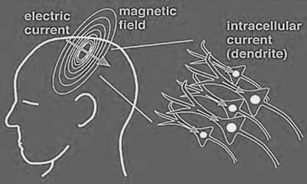
Fig.7

It is Similar to EEG but uses measurements of magnetic fields rather than electric fields .We measures the magnetic field generated by the brain outside the scalp, temporal resolution is better than EEG
- High cost
- difficulty in obtaining proper MEG readings
  - Ultra-sensitive magnetic field detectors are needed
  - Shielding from other magnetic sources are necessary
- Mobility is restricted

6.2 Invasive BCI research
Research has targeted repairing damaged sight and providing new functionality to paralysed people. Invasive BCIs are implanted directly into the grey matter of the brain during neurosurgery. As they rest in the grey matter, invasive devices produce the highest quality signals of BCI devices but are prone to scar-tissue build-up, causing the signal to become weaker or even lost as the body reacts to a foreign object in the brain. BCIs focusing on motor neuroprosthetics aim to either restore movement in paralyzed individuals or provide devices to assist them, such as interfaces with computers or robot arms. Invasive BCI approaches are based on recordings from ensembles of single brain cells (also known as single units) or on the activity of multiple neurons (also known as multi-units). These approaches have their roots in the pioneering studies conducted by Fetz and colleagues in the 1960s and 1970s. In these experiments, monkeys learned to control the activity of their cortical neurons voluntarily, aided by biofeedback indicating the firing rate of single neurons[3]. A few years after these experiments, Edward Schmidt raised the possibility that voluntary motor commands could be extracted from raw cortical neural activity and used to control a prosthetic device designed to restore motor functions in severely paralyzed patients.
Largely owing to technical difficulties associated with obtaining the needed cortical signals and implementing real-time interfaces quickly enough, thorough experimental testing of Schmidt’s proposition took almost two decades to be accomplished. These bottlenecks were passed because of a series of experimental and technological breakthroughs that led to a new electrophysiological methodology for chronic, multi-site, multi-electrode recordings. The BCI approach that relies on long-term recordings from large populations of neurons (100–400 units) evolved from experiments carried out in 1995. After the introduction of such an approach, a series of studies demonstrated that neuronal readout of tactile stimuli could be uncovered using pattern-recognition algorithms, such as artificial neural networks. These developments paved the way for the first experiment in which neuronal population activity recorded in behaving rats enacted movements of a robotic device that had a single degree of freedom. Soon after this first demonstration, a similar BCI approach was shown to work in New World and rhesus monkeys. As a result of these experimental efforts, in less than six years several laboratories reported BCIs that reproduced primate arm reaching and the combination of reaching and grasping movements, using either computer cursors or robotic manipulators as actuators. During the past three years, most of the published studies on BCIs have been conducted in behaving rhesus monkeys[1]. There are several important differences that distinguish these BCIs. These include: the number of cortical implants (e.g. uni-site or multi-site recordings); the cortical location of implants (e.g. frontal or parietal cortex, or both); the type of neural signal recorded (local field potentials versus single-unit or multi-unit signals) and the size of the neural sample
6.2.1 Electrocorticography (ECoG)
Fig.8 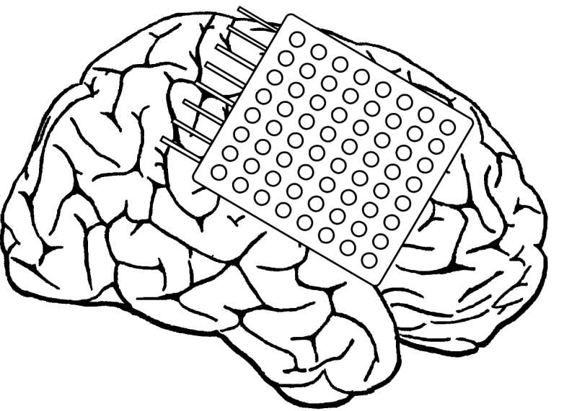

It measures the electrical activity of the brain taken from beneath the skull in a similar way to non-invasive electroencephalography, but the electrodes are embedded in a thin plastic pad that is placed above the cortex, beneath the dura mater. ECoG technologies were first trialed in humans in 2004 by Eric Leuthardt and Daniel Moran from Washington University in St Louis. In a later trial, the researchers enabled a teenage boy to play Space Invaders using his ECoG implant. This research indicates that it is difficult to produce kinematic BCI devices with more than one dimension of control using EcoG. The electrocorticogram is still considered to be the “gold” standard for defining epileptogenic zones; however, this procedure is risky and highly invasive. Recent studies have explored the development of a noninvasive cortical imaging technique for presurgical planning that can provide the same information and resolution of the invasive ECoG.
Integrating the information provided by a structural MRI and scalp EEG to provide a noninvasive alternative to ECoG. This study investigated a high-resolution subspace source localization approach, to image the locations and estimate the extents of current sources from the scalp EEG. A thresholding technique was applied to the resulting tomography of subspace correlation values in order to identify epileptogenic sources. This method was tested in three pediatric patients with intractable epilepsy, with encouraging clinical results. Each patient was evaluated using structural MRI, long-term video EEG monitoring with scalp electrodes, and subsequently with subdural electrodes. The ECoG data was then recorded from implanted subdural electrode grids placed directly on the surface of the cortex. MRI and computed tomography images were also obtained for each subject.
The epileptogenic zones identified from preoperative EEG data were validated by observations from postoperative ECoG data in all three patients. These preliminary results suggest that it is possible to direct surgical planning and locate epileptogenic zones noninvasively using the described imaging and integrating methods. EEG findings were further validated by the surgical outcomes of all three patients. After surgical resectioning, two patients are seizure-free and the third has experienced a significant reduction in seizures. Due to its clinical success, offering a promising alternative to preoperative EcoG[1], providing information about both the location and extent of epileptogenic sources through a noninvasive imaging procedure.
Pros
- higher spatial resolution
- better signal-to-noise ratio
- wider frequency range
- lesser training requirements than scalp-recorded EEG
Cons
- Clinical risk involved

6.2.2 Light Reactive Imaging.
BCI devices are still in the realm of theory. These would involve implanting a laser inside the skull. The laser would be trained on a single neuron and the neuron's reflectance measured by a separate sensor. When the neuron fires, the laser light pattern and wavelengths it reflects would change slightly. This would allow researchers to monitor single neurons but require less contact with tissue and reduce the risk of scar-tissue build-up.

7. Ratbot
Implanting electrodes into sensory bundles that signaled left and right whisker touches and also into the medial forebrain bundle, a pleasure center for rats. They learned that they could steer the rat by stimulating the whisker bundle on the desired side, and then stimulating the medial forebrain bundle when the rat moved in the desired direction. Each rat was fitted with a tiny head-mounted camera and light and a transmitter backpack that sent live video from the camera back to the human controller. The rats were able to negotiate mazes, climb stairs, and go through rubble piles, all while under the guidance of a controller who watched their progress on a screen. In the year 2000, Dr. John Chapin and Dr. Sanjiv Talwar of the State University of New York Downstate Medical Center began work on the development of thought-controlled prosthetic devices. They imagined an artificial hand that would grip and release as the owner willed it, or legs that would allow a paralyzed patient to walk and run naturally. Because of the relative simplicity of the rat brain, they first attempted to build a brain-machine link using a rat as a model. In Kobe japan, the 1995 earthquake led to 6,502 deaths nearly 4000 of who were due to suffocation. When a building collapses, heavy machinery must often be brought into the disaster site to rescue survivors, yet that very equipment has the potential to cause further injury to survivors. Furthermore, where does a rescuer look first? How can they get a look into the rubble to see where the survivors might be trapped without increasing danger? Rats are well-designed by nature to enter small places and scramble about. Remote-controlled rats could soon help searching earthquake survivors or leading bomb-disposal teams to buried land mines.

8. Principle of BCI operation
Invasive BMIs rely on the physiological properties of individual cortical and subcortical neurons (or pools of neurons) that modulate their activity in association with movements. First documented four decades ago by Evarts, such modulations are highly variable, from neuron to neuron and from trial to trial . Thus, as much as neighboring neurons might display highly distinct firing modulation patterns during the execution of a particular movement, single-neuron firing can vary substantially from one trial to the next, despite the fact that the overt movements remain virtually identical. By the same token, averaging across large populations of neurons significantly reduces the variability of signals derived from single neurons. Extracting motor control signals from the firing patterns of populations of neurons and using these control signalsto reproduce motor behaviours in artificial actuators are the two key operations that a clinically viable BCI should perform flawlessly. To be accepted by patients, BCI devices will also have to act in the same way and feel the same as the subjects’ own limbs. Recent findings suggest that this task might be accomplished by creating conditions under which the brain undergoes experience-dependent plasticity and assimilates the prosthetic limb as if it were part of the subject’s own body. Until recently, such plasticity was achieved using visual feedback. However, a more efficient way to assimilate the prosthetic limb in the brain representation could be to use multiple artificial feedback signals, derived from pressure and position sensors placed on the prosthetic limb. These feedback signals would effectively train the brain to incorporate the properties of the artificial limb into the tuning characteristic of neurons located in cortical and sub cortical areas that maintain representations of the subject’s body. We predict that such plasticity will result in sensory and motor areas of the brain representing the prosthetic device.

9. Scheme of BCI
A BCI involves extracting information from the highly complex EEG. This is usually achieved by extracting features from EEG signals recorded from subjects performing specific mental tasks. A class of features for each mental task is usually obtained from signals, pre-recorded whilst a subject performs a number of repetitions of each mental task. Subsequently a classifier is trained to learn which features belong to which class. This ultimately leads to the development of a BCI system that can determine which mental tasks are related to specific EEG signals and associate those EEG signals with the user’s intended communication.
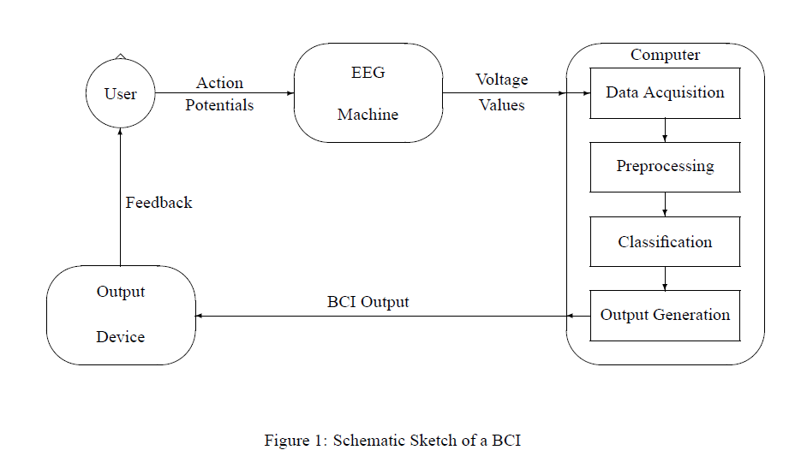

Fig.9
9.1 Pre-processing
The main task of a BCI is to recognize patterns by interpreting sequences of numbers. This automatically raises the question what these numbers are, i.e. where they come from. The BCI is confronted with (integer) values coming out of an analog-to-digital converter – digitizing the output of an EEG machine connected to the user – or a digital EEG machine at a rate of (typically) 100 – 300 Hz per channel as raw input data. As there are usually up to 32 channels, the system has to deal with up to 10000 values per second. Shovelling this huge amount of data in a neural net classifier might be a simple and the most straightforward way of analyzing the data. However, the classifier will most probably not find anything. In order to receive useful results, those parts containing the most important information – which is also a matter of representation – have to be extracted. Besides, since the raw data may be contaminated by all sorts of artefacts, it is not very wise to use them directly as input signal for the classifier.
This section introduces different methods developed to represent the data and to extract the important information from it. The methods include the Fast Fourier Transform (FFT), the Wavelet Transformation, Blind Signal Separation, and EOG Monitoring.
In order to analyze the data signal for its frequency content, it has to be converted from the time domain into the frequency domain. This can be accomplished by applying a mathematical method known as Fourier Transform.

9.2 Classification
In order to find out what the user wants, a BCI system has to classify the preprocessed data. This means that the system does not attempt to understand the user’s intentions, but it “compares” the data symbolizing a segment to representatives of a limited number of classes, and selects the class matched best. Those networks are designed in accordance with the brain as natural prototype, and there are numerous different architectures reported in the literature. Like their biological counterpart, they consist of a number of interconnected simple processing units, i.e. artificial neurons. The units are organized in layers, and most ANNs consist of an input layer, an output layer, and one or more layers in between. The ANN works like a “black box”, taking the input vector and generating an output vector, where the state of the neurons in the intermediate layers is invisible or “hidden”. The connection between two units is typically associated with an adjustable weight (the exact value of which is found during an initial training or learning phase), and the output of an artificial neuron (which is propagated to multiple successor neurons) is a function of the weighted sum of its inputs.

9.3 Translation algorithm
Currently, neuroscientists are far from obtaining a clear understanding of how motor and cognitive information is processed by the populations of neurons that form large brain circuits. Rate encoding, temporal encoding and population encoding principles have been suggested, and various experimental paradigms, including BCIs, have been developed to test the validity of these concepts. However, precise knowledge of computations performed by brain circuits is not crucial for the construction of clinically relevant BCIs. Mostly, BCI platforms take advantage of the well known correlation between discharges of cortical neurons and motor parameters of interest, and perform a reverse operation: they predict motor parameters from patterns of neuronal firing. Generally, predictions of motor parameters do not signify a causal relationship between the neuronal activity and the generation of movements. One type of correlation between neuronal activity and movement is known as directional tuning and correlations of neuronal activity with kinematic and kinetic parameters of movements have also been described. Although a wealth of linear and nonlinear algorithms for translating neuronal activity into commands to artificial actuators have been suggested, relatively simple multiple linear regression models have proved to be efficient in many practical BCI designs . In these models, predicted motor reliability of predictions improve considerably with the number of simultaneously recorded neurons, because motor information seems to be represented in the cortex in a highly distributed way. Thus, as the neuronal sample increases in size, errors related to individual neuron firing variability decrease significantly. So looking into the future, it seems unlikely that invasive BCIs based on a small group of neurons will be capable of continuously reproducing in artificial limbs the range of fine movements normally performed by the human arm and hand.

10. Brain Gate Technology

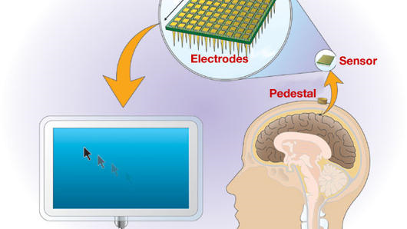
The BrainGate Neural Interface Device is a proprietary brain-computer interface that consists of an internal neural signal sensor and external processors that convert neural signals into an output signal under the users own control. The sensor consists of a tiny chip smaller than a baby aspirin, with one hundred electrode sensors each thinner than a hair that detect brain cell electrical activity.
The BrainGate technology platform was designed to take advantage of the fact that many patients with motor impairment have an intact brain that can produce movement commands. This may allow the BrainGate system to create an output signal directly from the brain, bypassing the route through the nerves to the muscles that cannot be used in paralysed people.
The chip is implanted on the surface of the brain in the motor cortex area that controls movement. In the pilot version of the device, a cable connects the sensor to an external signal processor in a cart that contains computers. The computers translate brain activity and create the communication output using custom decoding software. Importantly, the entire BrainGate system was specifically designed for clinical use in humans and thus, its manufacture, assembly and testing are intended to meet human safety requirements. Five quadriplegics patients in all are enrolled in the pilot study, which was approved by the U.S. Food and Drug Administration (FDA). 2004 An implantable, brain-computer interface the size of an aspirin has been clinically tested on humans by American company Cyberkinetics. The 'BrainGate' device can provide paralysed or motor-impaired patients a mode of communication through the translation of thought into direct computer control. The technology driving this breakthrough in the Brain-Machine-Interface field has a myriad of potential applications, including the development of human augmentation for military and commercial purposes.

11. Sensory Input
The most common and oldest way to use a BCI is a cochlear implant. For the average person, sound waves enter the ear and pass through several tiny organs that eventually pass the vibrations on to the auditory nerves in the form of electric signals. If the mechanism of the ear is severely damaged, that person will be unable to hear anything. However, the auditory nerves may be functioning perfectly well. They just aren't receiving any signals.
A cochlear implant bypasses the nonfunctioning part of the ear, processes the sound waves into electric signals and passes them via electrodes right to the auditory nerves. The result: A previously deaf person can now hear. He might not hear perfectly, but it allows him to understand conversations.
The processing of visual information by the brain is much more complex than that of audio information, so artificial eye development isn't as advanced. Still, the principle is the same. Electrodes are implanted in or near the visual cortex, the area of the brain that processes visual information from the retinas. A pair of glasses holding small cameras is connected to a computer and, in turn, to the implants. After a training period similar to the one used for remote thought-controlled movement, the subject can see. Again, the vision isn't perfect, but refinements in technology have improved it tremendously since it was first attempted in the 1970s. Jens Naumann was the recipient of a second-generation implant. He was completely blind, but now he can navigate New York City's subways by himself and even drive a car around a parking lot [source: CBC News]. In terms of science fiction becoming reality, this process gets very close. The terminals that connect the camera glasses to the electrodes in Naumann's brain are similar to those used to connect the VISOR (Visual Instrument and Sensory Organ) worn by blind engineering officer Geordi La Forge in the "Star Trek: The Next Generation" TV show and films, and they're both essentially the same technology. However, Naumann isn't able to "see" invisible portions of the electromagnetic spectrum.
12. BCI Vs Neuroprosthetics
Neuroprosthetics is an area of neuroscience concerned with neural prostheses—using artificial devices to replace the function of impaired nervous systems or sensory organs. The most widely used neuroprosthetic device is the cochlear implant, which was implanted in approximately 100,000 people worldwide as of 2006. There are also several neuroprosthetic devices that aim to restore vision, including retinal implants.
The differences between BCIs and neuroprosthetics are mostly in the ways the terms are used: neuroprosthetics typically connect the nervous system to a device, whereas the term "BCIs" usually connect the brain (or nervous system) with a computer system. Practical neuroprosthetics can be linked to any part of the nervous system, for example peripheral nerves, while the term "BCI" usually designates a narrower class of systems which interface with the central nervous system.
The terms are sometimes used interchangeably and for good reason. Neuroprosthetics and BCI seek to achieve the same aims, such as restoring sight, hearing, movement, ability to communicate, and even cognitive function. Both use similar experimental methods and surgical techniques.

13. BCI Innovators
A few companies are pioneers in the field of BCI. Most of them are still in the research stages, though a few products are offered commercially.
- Neural Signals is developing technology to restore speech to disabled people. An implant in an area of the brain associated with speech (Broca's area) would transmit signals to a computer and then to a speaker. With training, the subject could learn to think each of the 39 phonemes in the English language and reconstruct speech through the computer and speaker [source: Neural Signals].
- NASA has researched a similar system, although it reads electric signals from the nerves in the mouth and throat area, rather than directly from the brain. They succeeded in performing a Web search by mentally "typing" the term "NASA" into Google [source: New Scientist].
- Cyberkinetics Neurotechnology Systems is marketing the BrainGate, a neural interface system that allows disabled people to control a wheelchair, robotic prosthesis or computer cursor [source: Cyberkinetics].
- Japanese researchers have developed a preliminary BCI that allows the user to control their avatar in the online world Second Life [source: Ars Technica].

14. Drawbacks
- The brain is incredibly complex. To say that all thoughts or actions are the result of simple electric signals in the brain is a gross understatement. There are about 100 billion neurons in a human brain [source: Greenfield]. Each neuron is constantly sending and receiving signals through a complex web of connections. There are chemical processes involved as well, which EEGs can't pick up on.
- The signal is weak and prone to interference. EEGs measure tiny voltage potentials. Something as simple as the blinking eyelids of the subject can generate much stronger signals. Refinements in EEGs and implants will probably overcome this problem to some extent in the future, but for now, reading brain signals is like listening to a bad phone connection. There's lots of static.
- The equipment is less than portable. It's far better than it used to be -- early systems were hardwired to massive mainframe computers. But some BCIs still require a wired connection to the equipment, and those that are wireless require the subject to carry a computer that can weigh around 10 pounds. Like all technology, this will surely become lighter and more wireless in the future.
- BCI researchers have yet to attract the attention of animal rights groups. It may also be because BCIs are being used to acquire signals to control devices rather than the other way around, although vision research is the exception to this.
This ethical debate is likely to intensify as BCIs become more technologically advanced and it becomes apparent that they may not just be used therapeutically but for human enhancement. Today's brain pacemakers, which are already used to treat neurological conditions such as depression could become a type of BCI and be used to modify other behaviors. Neurochips could also develop further, for example the artificial hippocampus, raising issues about what it actually means to be human.
- Some of the ethical considerations that BCIs would raise under these circumstances are already being debated in relation to brain implants and the broader area of mind control.
15. Ethical Consideration
Discussion about the ethical implications of BCIs has been relatively muted. This may be because the research holds great promise in the fight against disability and BCI researchers have yet to attract the attention of animal rights groups. It may also be because BCIs are being used to acquire signals to control devices rather than the other way around, although vision research is the exception to this.
This ethical debate is likely to intensify as BCIs become more technologically advanced and it becomes apparent that they may not just be used therapeutically but for human enhancement. Today's brain pacemakers, which are already used to treat neurological conditions such as depression could become a type of BCI and be used to modify other behaviours. Neurochips could also develop further, for example the artificial hippocampus, raising issues about what it actually means to be human.Some of the ethical considerations that BCIs would raise under these circumstances are already being debated in relation to brain implants and the broader area of mind control.
16. BCI Outlook
Artificial sensory channel

- A cochlear implant (CI) is a surgically implanted electronic device that provides a sense of sound to a person who is profoundly deaf or severely hard of hearing. The cochlear implant is often referred to as a bionic ear. Unlike hearing aids, the cochlear implant does not amplify sound, but works by directly stimulating any functioning auditory nerves inside the cochlea with electric field stimulated through an electric impulse
- In vision science, direct brain implants have been used to treat non-congenital (acquired) blindness. One of the first scientists to come up with a working brain interface to restore sight was private researcher William Dobelle.The Dobelle artificial vision system feeds images from a digital camera to a belt-mounted signal processor. From the belt-mounted signal processor, the Dobelle artificial vision system sends the images through the skull, and into the visual cortex. From the belt-mounted signal processor, the Dobelle artificial vision system sends the images through the skull, and into the visual cortex [6].
- More than 200,000 patients live with the motor sequelae of traumas in USA. There are two ways to help them restore some motor function:
- Repair the damaged nerve axons
- Build neuroprothetic device
- Deep brain stimulation (DBS) may suppress the symptoms of neurological disorders such as essential tremor and Parkinson's disease.Since 1997, more than 25,000 DBS recipients worldwide. The deep brain stimulation system consists of three components: the implanted pulse generator (IPG), the lead, and the extension. The IPG is a battery-powered neurostimulator encased in a titanium housing, which sends electrical pulses to the brain to interfere with neural activity at the target site. The lead is a coiled wire insulated in polyurethane with four platinum iridium electrodes and is placed in one of three areas of the brain. The lead is connected to the IPG by the extension, an insulated wire that runs from the head, down the side of the neck, behind the ear to the IPG, which is placed subcutaneously below the clavicle or in some cases, the abdomen. The IPG can be calibrated by a neurologist, nurse or trained technician to optimize symptom suppression and control side effects. DBS leads are placed in the brain according to the type of symptoms to be addressed. For non-Parkinsonian essential tremor the lead is placed in the ventrointermedial nucleus (VIM) of the thalamus. For dystonia and symptoms associated with Parkinson's disease (rigidity, bradykinesia/akinesia and tremor), the lead may be placed in either the globus pallidus or subthalamic nucleus. All three components are surgically implanted inside the body. Under local anesthesia, a hole about 14 mm in diameter is drilled in the skull and the electrode is inserted, with feedback from the patient for optimal placement. The installation of the IPG and lead occurs under general anesthesia. The right side of the brain is stimulated to address symptoms on the left side of the body and vice versa.
17. Cell culture BCI
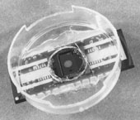
Fig.7
Researchers have built devices to interface with neural cells and entire neural networks in cultures outside animals. As well as furthering research on animal implantable devices, experiments on cultured neural tissue have focused on building problem-solving networks, constructing basic computers and manipulating robotic devices. Research into techniques for stimulating and recording from individual neurons grown on semiconductor chips is sometimes referred to as neuroelectronics or neurochips.
In 2006, a team led by Theodore Berger at the University of Southern California started work on a neurochip designed to function as an artificial or prosthetic hippocampus. The neurochip was designed to function in rat brains and is intended as a prototype for the eventual development of higher-brain prosthesis. The hippocampus was chosen because it is thought to be the most ordered and structured part of the brain and is the most studied area. Its function is to encode experiences for storage as long-term memories elsewhere in the brain.

18. References
- Communication Technologies Based on Brain Activity Avid Roman Gonzalez TELECOM ParisTech
- Nicolelis, M. A. L. Actions from thoughts
- Wolpaw, J. R., et al. Brain-computer interfaces for communication and result. Clinical neurophysiology
- www.wired.com
- Kennedy, P. R., et al. “Direct Control of a Computer from the Human Central Nervous System. IEEE paper on Neural Sys. June 2009.
- Wikipedia.org
- Howstuffworks.com

